|  |
| --- |
| **Shannon Foynes Port Company**  **Notice To Mariners**  **Notice No. 6 of 2021** |

**SHANNON ESTUARY**

**ANCHORAGE J**

**To All Ship Owners, Operators, Masters and Agents**

Please be advised that Anchorage J has been fouled by anchor and 9 shackles of chain.

The approximate position of foul is 52 35.8N and 009 33.0W.

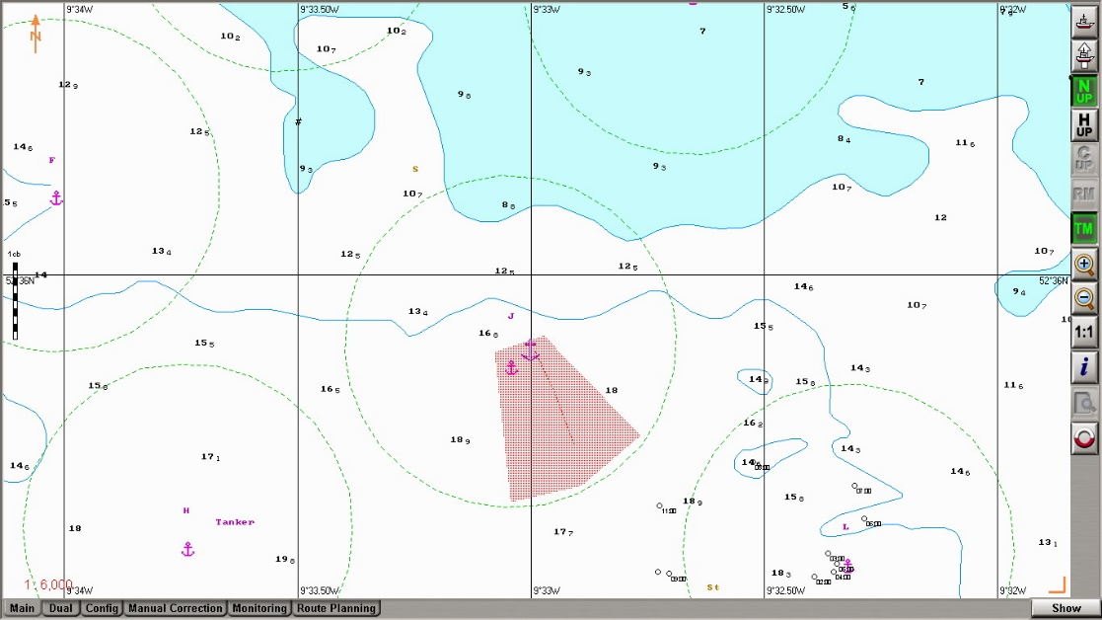

This anchorage position is not to be used by any vessels until further notice.

BY ORDER,

Hugh Conlon

Harbour Master

Shannon Foynes Port Company

1st January 2021